**Setting up SDL on Windows**

To build and run the game you need to download SDL2-devel-2.0.3-mingw.tar.gz (MinGW 32/64-bit) from <https://www.libsdl.org/download-2.0.php>

The following development libraries need also to be downloaded:

<https://www.libsdl.org/projects/SDL_image/release/SDL2_image-devel-2.0.0-mingw.tar.gz>

<https://www.libsdl.org/projects/SDL_mixer/release/SDL2_mixer-devel-2.0.0-mingw.tar.gz>

<https://www.libsdl.org/projects/SDL_ttf/release/SDL2_ttf-devel-2.0.12-mingw.tar.gz>

Extract the archives (I extracted them on C:\).

**Setting up a Code::Blocks Project with SDL on Windows**

Go to this page http://www.codeblocks.org/downloads/binaries and download codeblocks-13.12mingw-setup-TDM-GCC-481.exe.

Launch Code::Blocks. Click on File->Open.

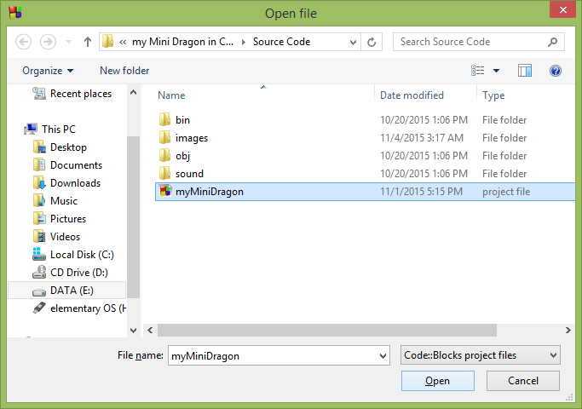

You should now see the source files on the left pane of the Code::Blocks IDE like so

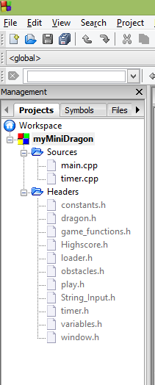

Next go to Settings -> Compiler.

Make sure you have selected Have g++ follow the C++11 ISO C++ language standard [-std=c++0x]

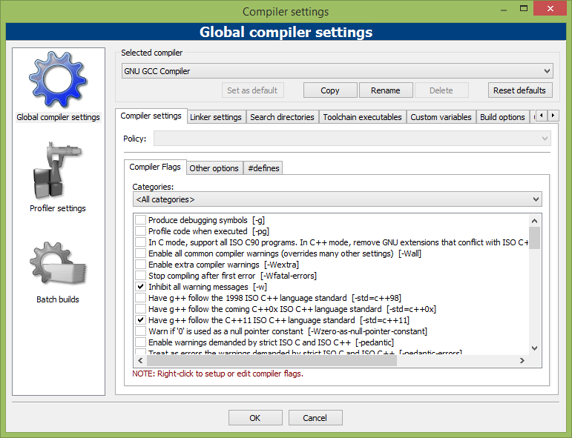

Select the "Search directories" and add the include folders (if you extracted to C:\ like I did, if not put your extracted folders path):

C:\SDL2-2.0.3\i686-w64-mingw32\include\SDL2

C:\SDL2_ttf-2.0.12\i686-w64-mingw32\include\SDL2

C:\SDL2_mixer-devel-2.0.0-mingw\SDL2_mixer-2.0.0\i686-w64-mingw32\include\SDL2

C:\SDL2_image-2.0.0\i686-w64-mingw32\include\SDL2

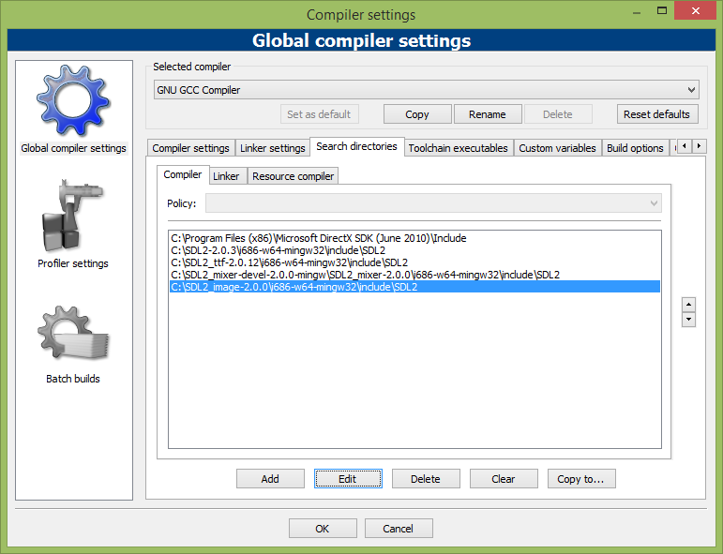

then with the "Search directories" tab still selected select the "Linker" tab and add the library paths

C:\SDL2-2.0.3\i686-w64-mingw32\lib

C:\SDL2_mixer-devel-2.0.0-mingw\SDL2_mixer-2.0.0\i686-w64-mingw32\lib

C:\SDL2_image-2.0.0\i686-w64-mingw32\lib

C:\SDL2_ttf-2.0.12\i686-w64-mingw32\lib

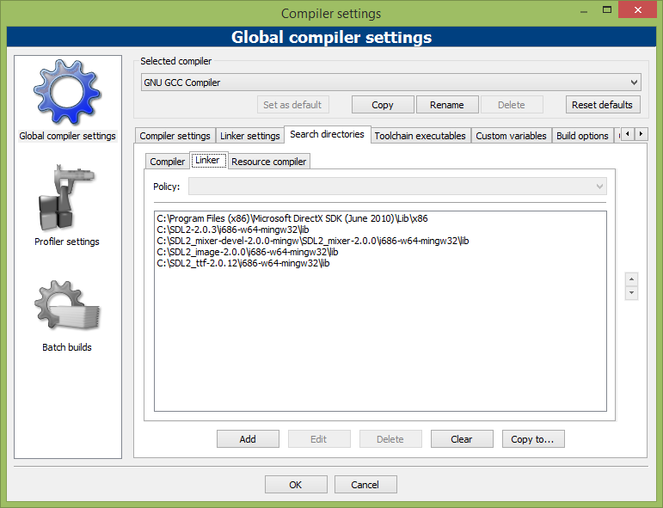

then select the "Linker Settings" tab and add the following to "Other linker options:"

-lmingw32 -lSDL2main -lSDL2 -lSDL2_image -lSDL2_ttf -lSDL2_mixer

then click OK.

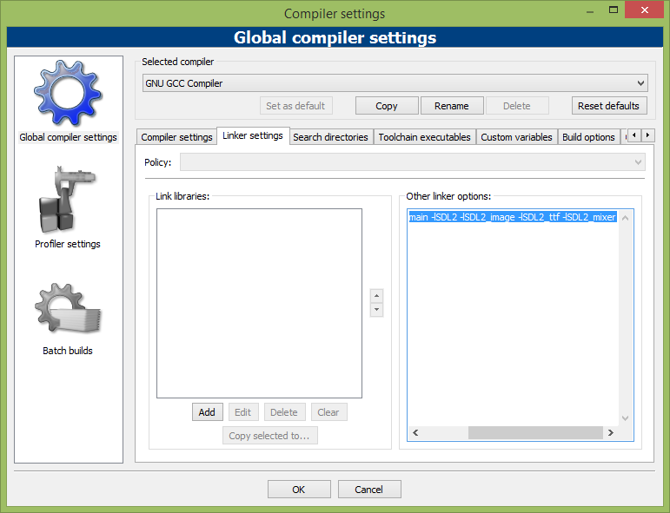

At this point the program will build but it will not run until we put the runtime dlls and the data into the correct locations. If you try to run it you will most likely get a dialog saying the SDL.dll cannot be found (unless you have it in a system folder on the path).

The working folder when running a program from within the Code::Blocks IDE is the folder that the project file (*.cbp) is stored in. Make sure you have the following dlls:

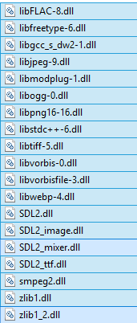

into that folder. It is convenient to have this as the working folder because Debug and Release targets can be run without having to have the data and dlls in two locations. When you run the .exe directly by double-clicking it, the working folder is the folder the .exe is in, so the dlls and data would need to be located there when launching the program outside the IDE.